UX Design & Development Services KIMJAYDOT, LLC

UX Case Study

**Prepared For:**

Vera Wang and Jorge Hernandez

ReminderX

**Prepared by:**

Kimberley Johnson

KIMJAYDOT, LLC

October 18, 2023

(281)-813-4128

[www.kimjaydot.com](https://kimjaydot.com/)

Table of Contents

## **Proposal**

### Introduction ………………………………………………………………………………………………………………………. Page 4 Background………………………………………………………………………………………………………………………….Page 4

### Project Goals..………………………………………………………………………………………………………………………Page 5

### Project Activities…….…………………………………………………………………………………………….……………. Page 5

### Project Scope…..…..………………………………………………………………………………………………………………Page 6

### Project Deliverables…………………………………………………………………………………………………………Pages 6 -7

### Responsibility Matrix………………………………………………………………………………………………………….. Page 7

### Timeline of Project Activities…….………………………………………………………………………………………….Page 8

### Project Sign-off and **Acknowledgment** Agreement…………………..………………………………………….Page 8

## **User Study Interviews**

### Project Overview and Research Goals.…………………..…………………………………………………………….Page 9

### Research Method.…………………..…………………………………………………………………………………………..Page 9

## **Shared Vision**

### Introduction…………………..………………………………………………………………………………………………….Page 10

### Research Approach …………………..………………………………………………………………………………………Page 10

### Findings and Recommendations …………………..…………………………………………………………………..Page 11

### User Persona…………………..…………………………………………………………………………………………………Page 12

### Design Tenets…………………..………………………………………………………………………………………………. Page 13

## **Low-Fidelity Wireframes**

### #1 Getting Started | Low-Fidelity Wireframes …………………..………………………………………………Page 14

### #2: Home/How-To-Videos | Low Fidelity Wireframes……..…………………………………………………Page 15

### #3: Navigation Bar (Calendar & To-Do Buttons) and Adding To-Dos Low-Fidelity Wireframes

### ……………………………………………………………………………………………………………………………………Pages 16-17

### #4: Alarms Notifications Low-Fidelity Wireframes……………………………………………………………..Page 18

Table of Contents – Continued

## **High-Fidelity Wireframes**

### #1: Getting Started | High-Fidelity Wireframes……………………………………………………………Pages 19 -20

### #2: Home/How-To-Videos | High-Fidelity Wireframes……………………………………………………….Page 21

### #3: Navigation Bar (Calendar & To-Do Buttons) and Adding To-Dos | High-Fidelity……..Pages 23-24

### #4: Alarms Notifications | High-Fidelity Wireframes…………………………………………………………..Page 25

## **Prototypes**

### Interactive Prototype…………………………………………………………………………………………………………Page 26

## **Lessons Learned**

### What I Learned…………………………………………………………………………………………………………………..Page 26

Proposal

# Introduction

This document serves as a proposal for ReminderX by UX Practitioner Kimberley Johnson.

ReminderX is a company co-founded by Vera and Jorge; they are a team building a to-do list and reminder application for a diverse audience worldwide that will be accessible on mobile devices and the web.

Kimberley Johnson has been tasked to work as a problem solver and designer to help ReminderX get through the eight phases on their to-do list and reminder application, which are:

1. **User Research Phase**
   1. Conduct interviews, understand the company's target audience, and do a competitive analysis with other similar applications to determine strengths and weaknesses.
2. **Planning Phase**
   1. Create personas, organize information architecture, describe how users interact with the application, and set goals and objectives.
3. **Design Phase**
   1. Create wireframes and prototypes, review visual design and branding, and perform usability testing.
4. **Development Phase**
   1. Communicate with a team of front-end and back-end developers and engineers.
5. **Testing Phase**
   1. Test application with real users.
6. **Launch Phase**
   1. Deploy the application to the intended audience.
7. **Post Launch Phase**
   1. Gather feedback, analyze data, and do regular maintenance.
8. **Evaluation Phase**
   1. Measure ReminderX’s product success rate.

# Background

ReminderX is currently in the initial stages of designing cross-platform interfaces for the web, iPhone, and Android devices. The company wants to ensure users can interact as a team and share their to-do list with others. ReminderX’s target audience will be students and business professionals who primarily have used daily planners/notebooks to write their daily activities and get them to transition into using ReminderX.

Individuals have faced challenges managing tasks and staying on top of their commitments. ReminderX aims to solve issues by creating compelling features, creating a seamless user experience with their application, and enhancing organizational skills and productivity.

# Project Goals

Our main goal for ReminderX is to create an application that helps individuals manage their tasks and stay organized by creating a user-friendly interface design that is intuitive for all users and is available on the web and mobile devices.

Here are several key features we want to incorporate for ReminderX:

* **Task Management**: Users can create, edit, and categorize to-do lists.
* **Cross-Platforms:** Cross-platform compatibility with iOS, Android, and web browsers.
* **Cloud Syncing:** Have a to-do list available to sync on the cloud.
* **Team Sharing:** Make custom features like sharing to-do lists with a group/team.
* **Priority Ranking:** Priority ranking from low to medium to high on to-do lists.
* **Reminders and Notifications:**  Receive timely reminders and set due dates.
* **Recurring Tasks:** Set up reoccurring tasks that are either daily, weekly, monthly, or custom.
* **Confirmation Alerts:** Set up alarm reminders five minutes before to ensure that tasks are completed.

# Project Activities

ReminderX’s application is a project dedicated to creating enhanced features, providing top functionality, and having a user-centric design that encourages users to manage their tasks effectively. As we go into the project’s scope and deliverables, we aim to streamline how users prioritize their daily tasks through their to-do lists and reminders.

1. **Identify Target Audience and User Research:** Gather information by conducting interviews and surveys.
2. **Ideation:** Create sketches and low-fidelity wireframes of the beginning stages of design.
3. **Prototyping:** Create an interactive application.
4. **User Testing:** Have individuals such as students and professionals test applications for errors and provide feedback.
5. **Development**:Implement functionality and core features.
6. **Launch:** Launch the application on the iOS App, Android’s Play Store, and the web.
7. **Marketing:** Promote advertisements for products.
8. **Training & Support:** Provide how-to guides and resources for all end-users and facilitate ongoing tech support to troubleshoot issues.

# Project Scope

This project scope defines specific objectives and the deliverables required to develop an intuitive, cross-platform application to improve task management and enhance user productivity.

## Features (What the Application should include)

* User Registration and login process
* Custom categories to group to-do lists and reminders
* Team sharing with user profiles
* Integration with calendars from Google, Outlook, and Mobile devices
* Able to sync across different devices
* Task management with to-do lists and reminders

## Platforms

* Make the application cross-compatible on iOS, Android, and web platforms

## Aesthetics, Branding, and Design

* Establish branding identity for visual design
* Create user-friendly interfaces

## Scalability

* Determine the potential for user base expansion

## Security

* Specify how user roles and permissions will be managed within the application
* Have privacy policies in place to inform users how ReminderX collects their data

# Project Deliverables

This proposal outlines critical components and features we plan to incorporate into ReminderX, ensuring this application becomes a solution for all task management and reminder needs. We plan to continuously update and communicate our process with stakeholders and team members.

### Project Proposal

* A documentation for ReminderX’s team members that highlights the projects goals, scopes, and deliverables.

### Define Target Audience and User Research

* Interviewing students from universities and business professionals who have used task management, to-do lists, and reminder applications in the past to collect insights.
* Create four user personas, gathering their backgrounds, goals, pinpoints, and narratives.

### UX Design

* Create user flows, low & high-fidelity wireframes, and navigation structures for information architecture.

### Visual Design

* Set a style guide that includes typography, branding colors, and icons.

### Application Development

* Build, code, and integrate features such as task management, team sharing, cloud syncing, confirmation alerts, priority ranking, reminders and notifications, cross-compatibility with web and mobile devices, and custom recurring tasks.

### Responsive Design & Accessibility

* Ensure user interface designs adapt to various viewports and applications by following Section 508, Compliance for Accessibility.

### Feedback and Iteration

* Explain the process of integrating feedback from stakeholders and users into the design and provide a schedule for implementing revisions.

### Project Timeline Status

* Update the Project Manager and team members on the milestones of each deliverable and provide deadlines for each project.

### Marketing

* Create a marketing plan that promotes the application through advertisements and social media campaigns.

### Maintenance and Training

* Schedule a maintenance routine to fix bugs, upgrade the application's features, and provide updates to users.
* Schedule training sessions with stakeholders and users.

# Responsibility Matrix

|  |  |
| --- | --- |
| **Project Manager** | Oversee project and ensure the team is following strict deadlines for deliverables and communicate with team |
| **UX Practitioner & Designers** | Compile User Research information from users, create user personas and make wireframes and interactive prototypes |
| **UI Designers** | Establish branding identity for Visual Design |
| **Front-End & Back-End Developers & Engineers** | Web Development for application, create blueprints and specifications |
| **Quality Assurance Team** | Tests functionality of application and reviews designs |
| **Technical Support** | Provide technical support to users who have questions about how to use the application or if they have trouble using the application |

# **­­Timeline of Project Activities**

The estimate of completion of Reminder’s application will take 12-18 months. This is a guide to meeting our deadlines with the following projects.

* **User Research:** 1- 2 Months
* **Wireframes & Prototyping:** 3- 4 Months
* **Development:** 5-9 Months
* **Visual Design:** 10-12 Months
* **Deployment & Testing:** 12- 18 Months

# **Project Sign-Off and Acknowledgment Agreement**

We acknowledge and now sign off on RemiderX's proposal for the to-do list and reminder application. We understand and accept the scope, goals, and objectives this proposal outlines and are committed to progressing with this project.

## Project Stakeholders

**Kimberley Johnson**

**Title:** UX Practitioner & Designer

**Company:** KIMJAYDOT, LLC

**Date:** 10/20/2023

**Vera Wang**

**Title:** Project Manager & Co-founder

**Company:** ReminderX

**Date:** 10/20/2023

**Jorge Hernandez**

**Title:** Engineer & Co-founder

**Company:** ReminderX

**Date:** 10/20/2023

This sign-off signifies our mutual agreement and commitment to the goals and objectives outlined in the proposal. We look forward to a productive and successful partnership in bringing this project to life.

**Kimberley Johnson**

Kimberley Johnson

**Vera Wang**

Vera Wang

**Jorge Hernandez**

Jorge Hernandez

User Study Interviews

# Project Overview and Research Goals

**Project Stakeholders:** Vera Wang and Jorge Hernandez

**Moderator:** Kimberley Johnson

**Study Dates:** October 23 – 25, 2023

**Location:** Pearland, Texas

ReminderX is a software company developing a to-do list and reminders application primarily for students and business professionals. Our mission is to build a user-friendly interface so users can effectively manage their tasks, get timely reminders of their activities/responsibilities, and stay organized for their goals.

The goals we would like to achieve for our users are:

* Understand how users keep track of their tasks, goals, or commitments.
* Evaluate users’ ability to organize and prioritize their tasks.
* Determine any challenges users face when attempting to complete tasks.

# Research Method

Kimberley Johnson and her research team will conduct a user study interview to obtain real-time insights and data from four participants, encompassing a diverse range of individuals, including students and business professionals of both genders.

During these interviews, I will ask how our users handle their tasks and if they already use a to-do list and reminder or task management applications.

Our goals for this user study interview are:

1. Investigate how users can effectively prioritize and complete their tasks using the application.
2. Identify user preferences, pain points, and challenges related to task prioritization and completion.
3. Analyze the user experience to enhance the application's features, design, and functionality in alignment with task management.

The user study interviews will last 15 to 20 minutes per session and will be recorded in audio format to capture the participant's responses.

Shared Vision

# Introduction

Kimberley Johnson is a User Experience Practitioner for ReminderX who is helping transform users' lives and can help them accomplish their daily tasks by using ReminderX’s to-do list and reminders application. She plays an essential role in enhancing the user experience. Here's an overview of what Kimberley does for the product team and why it's important.

1. **User Research** – Kimberley is responsible for conducting interviews with a specific target audience of business professionals and students who struggle with task management and still use traditional methods such as notepads and non-digital calendars. Kimberley aims to understand these users' challenges when accomplishing their daily tasks. By gathering insights, Kimberley can help the team make informed design decisions.
2. **User Persona** – Kimberley can create a persona highlighting goals, behaviors, pain points, and user background based on the user research findings. Personas assist the product team in focusing on the most essential features and design elements for the key user groups.

1. **Information Architecture** – Kimberley is responsible for understanding the challenges faced with a to-do list and reminder applications. Creating an organized navigation of a digital calendar view, creating a to-do list of categories, showing completed tasks, and having a clock reminder will create a friendly user interface and seamless experience.
2. **Wireframing & Prototyping** – Kimberley's responsibility includes designing wireframes and interactive prototypes for ReminderX's stakeholders, enabling them to visualize their concepts. These visuals help the team outline the layout's structure, design, and possible functionality, which can then be passed on to the development team.

# Research Approach

Kimberley Johnson conducted brief interviews lasting between 8 to 12 minutes each. The participants were one male and three females, all employed in various professions. The interview questions focused on their task management methods, especially their use of alternatives of a to-do list and reminder applications and their preferred methods of receiving reminders.

By exploring how these participants handle their daily tasks using conventional task management techniques, we aim to gain insights to develop an efficient user interface for our to-do list and reminders application.

# Findings and Recommendations

In the synthesis of findings from our interviews with four participants in ReminderX's user study, a common thread emerged. Most participants preferred traditional approaches when managing to-do lists and reminders, including using physical notepads and relying on a calendar.

However, a common issue was found among these participants. They frequently encountered challenges associated with traditional methods. These participants expressed misplacing their written notes for their tasks and needing to remember what they did.

Our feedback from our interviewees included that two participants didn’t have any experience using a to-do list and reminders application on the web or mobile for personal use. However, one participant had experience using a to-do list and reminders application at work.

Two participants mentioned that they want voice commands to input their tasks and have the voice prompt them that their task is complete.

Two participants also mentioned that their reminders should integrate with an alarm clock to track when they need to finish their tasks by accompanying a loud sound.

In our interviews, most participants reported utilizing a calendar for task management and expressed a strong desire to have a monthly calendar view as a feature for this application.

In synthesizing the data collected from our research sessions, it becomes evident that ReminderX's target users prioritize specific features in a to-do list and reminders application. A desire for a user-friendly interface with critical elements drives these preferences. These include incorporating an attention-grabbing alert sound to remind users of their tasks, providing a comprehensive digital calendar overview, seamlessly integrating an alarm clock function, having a completed to-do list of items indicated by a checkmark rather than disappearing, and having video tutorials to teach users how to use our application. These conclusions are supported by the feedback and insights shared by our participants.

# User Persona

# Design Tenets

**User-Friendly Interface**

Our design philosophy is the principle of user-friendliness. Our approach uses intuitive icons and buttons, empowering users to create, edit, or delete to-do list items effortlessly. Our application includes an overview of a monthly calendar to view tasks. When users view their to-do list items, they can mark completed items by selecting a checkmark that will turn green. The completed tasks will move into a different category so the user can check what they have previously done without disappearing. We provide a straightforward navigation that ensures that users can quickly grasp what steps to take next.

**Inclusivity and Accessibility**

We aim to create an inclusive application that caters to users from diverse age groups, backgrounds, and those with disabilities. Our application integrates advanced features such as voice commands and screen reader compatibility, ensuring a seamless experience. Our commitment is to meet the standards of Section 508 Compliance.

**User Training**

Facilitating user training is essential for us, especially for users who don’t have experience using digital applications. We offer comprehensive how-to guides and instructional videos to help users fully grasp the app's features and capabilities. This approach ensures that users can confidently navigate our application, eliminating confusion and intimidation and enabling them to enjoy a user-friendly experience.

**Cross-Platform Compatibility and Syncing Data:**

Our application works on the web, mobile, and desktop platforms. Users can log in from any platform and expect their data to be consistently and instantly synchronized. This ensures users remember their tasks from any device without losing information.

Low-Fidelity Wireframes

# #1: Getting Started | Low-Fidelity Wireframes

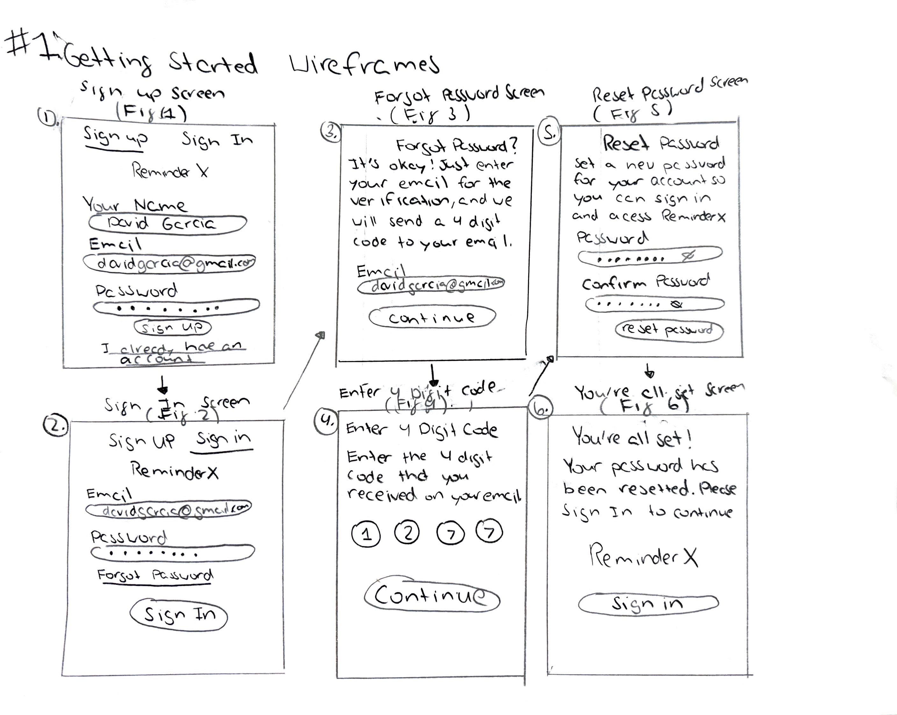

1. **Sign-Up Screen (Fig 1)**

Once the application is downloaded to the phone, the user will be taken to the Sign-Up Screen to enter their name, email, and password. They can select the Sign-Up button to create an account. They can select the "Sign In” or "I already have an account" links if they have an account.

1. **Sign-In Screen (Fig 2)**

If the user selects the “Sign In" or "I already have an account" links, they can enter their credentials and select the Sign In button to access the application.

1. **Forgot Password Screen (Fig 3)**

If the user selects Forgot Password from (Fig 2), they will be taken to the Forgot Password Screen. The user will enter their email to be sent a 4-digit code. The user will select the continue button.

1. **Enter the 4-digit Code Screen (Fig 4)**

The user will enter the 4-digit code and select continue to reset their password.

1. **Reset Password Screen (Fig 5)**

The user can enter their new password and confirm it. After that, they will select the reset password button.

1. **You're all Set Screen (Fig 6)**

The user's password has been reset. They can select the sign-in button to log into their account.

# #2: Home/How-To-Videos Low-Fidelity Wireframes

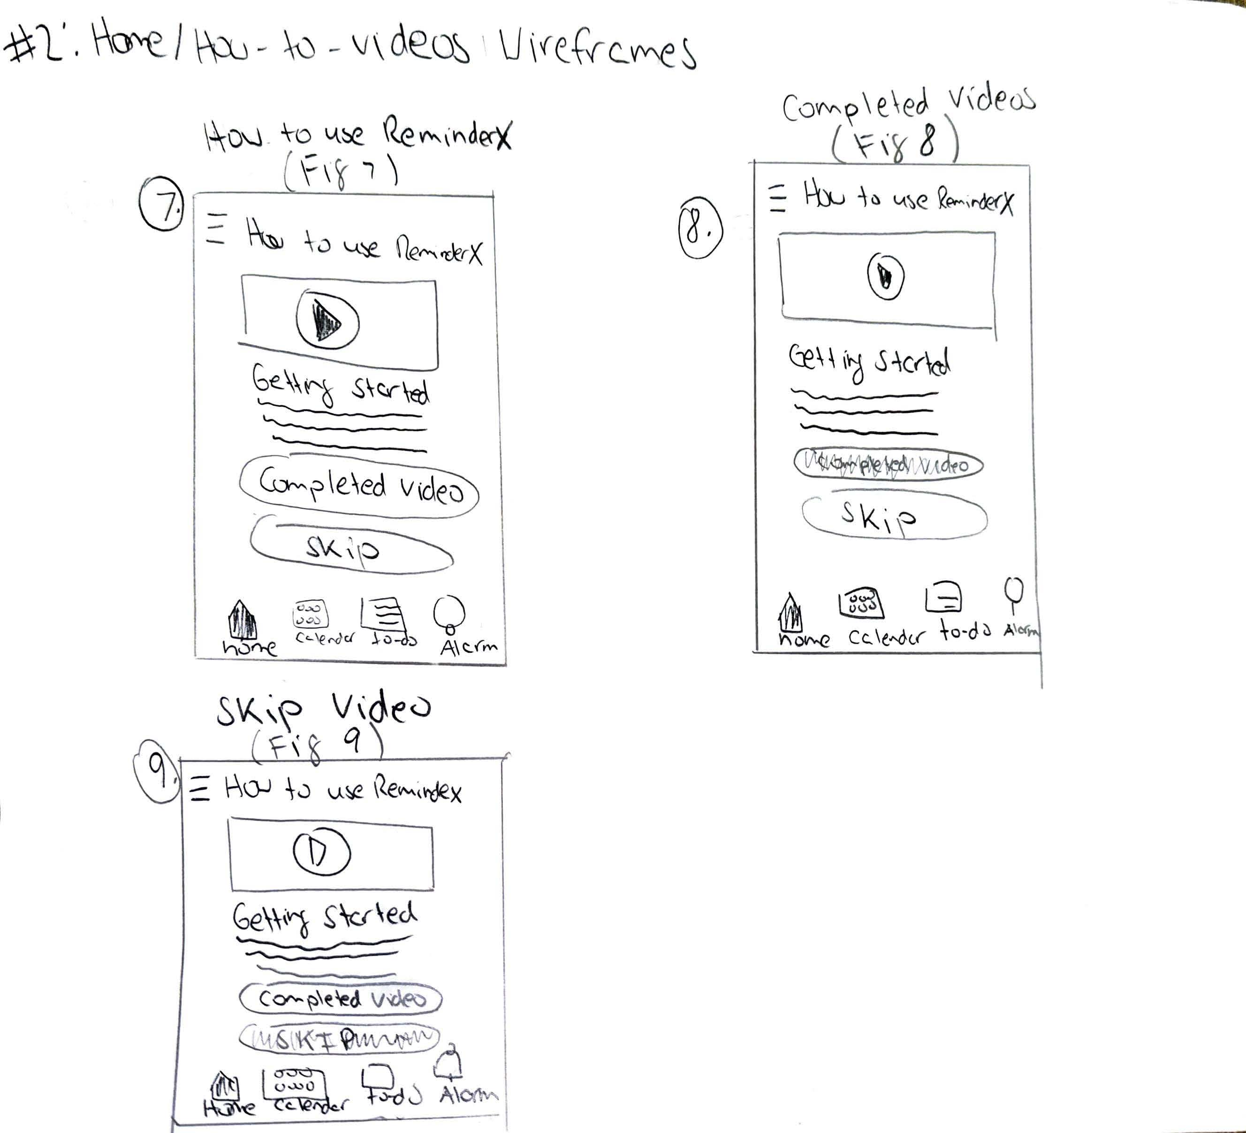

1. **How to Use ReminderX (Fig 7)**

Once the user logs into their account, they will be taken to the home screen. The home button will be the only active button, while the rest of the buttons from the navigation (calendar, to-do, and alarm) will be grayed out and not clickable. The user has a choice of watching the video or skipping the video. Once the user finishes the video, they can select the completed video button, or they can select the skip button.

1. **Completed Videos (Fig 8)**

When the user selects the completed video button, the rest of the navigation will be active for the user to select.

1. **Skip Video (Fig 9)**

When the user selects the skip button, the rest of the navigation will be active for the user to select.

# #3: Navigation Bar (Calendar & To-Do Buttons) and Adding To-Dos | Low-Fidelity Wireframes

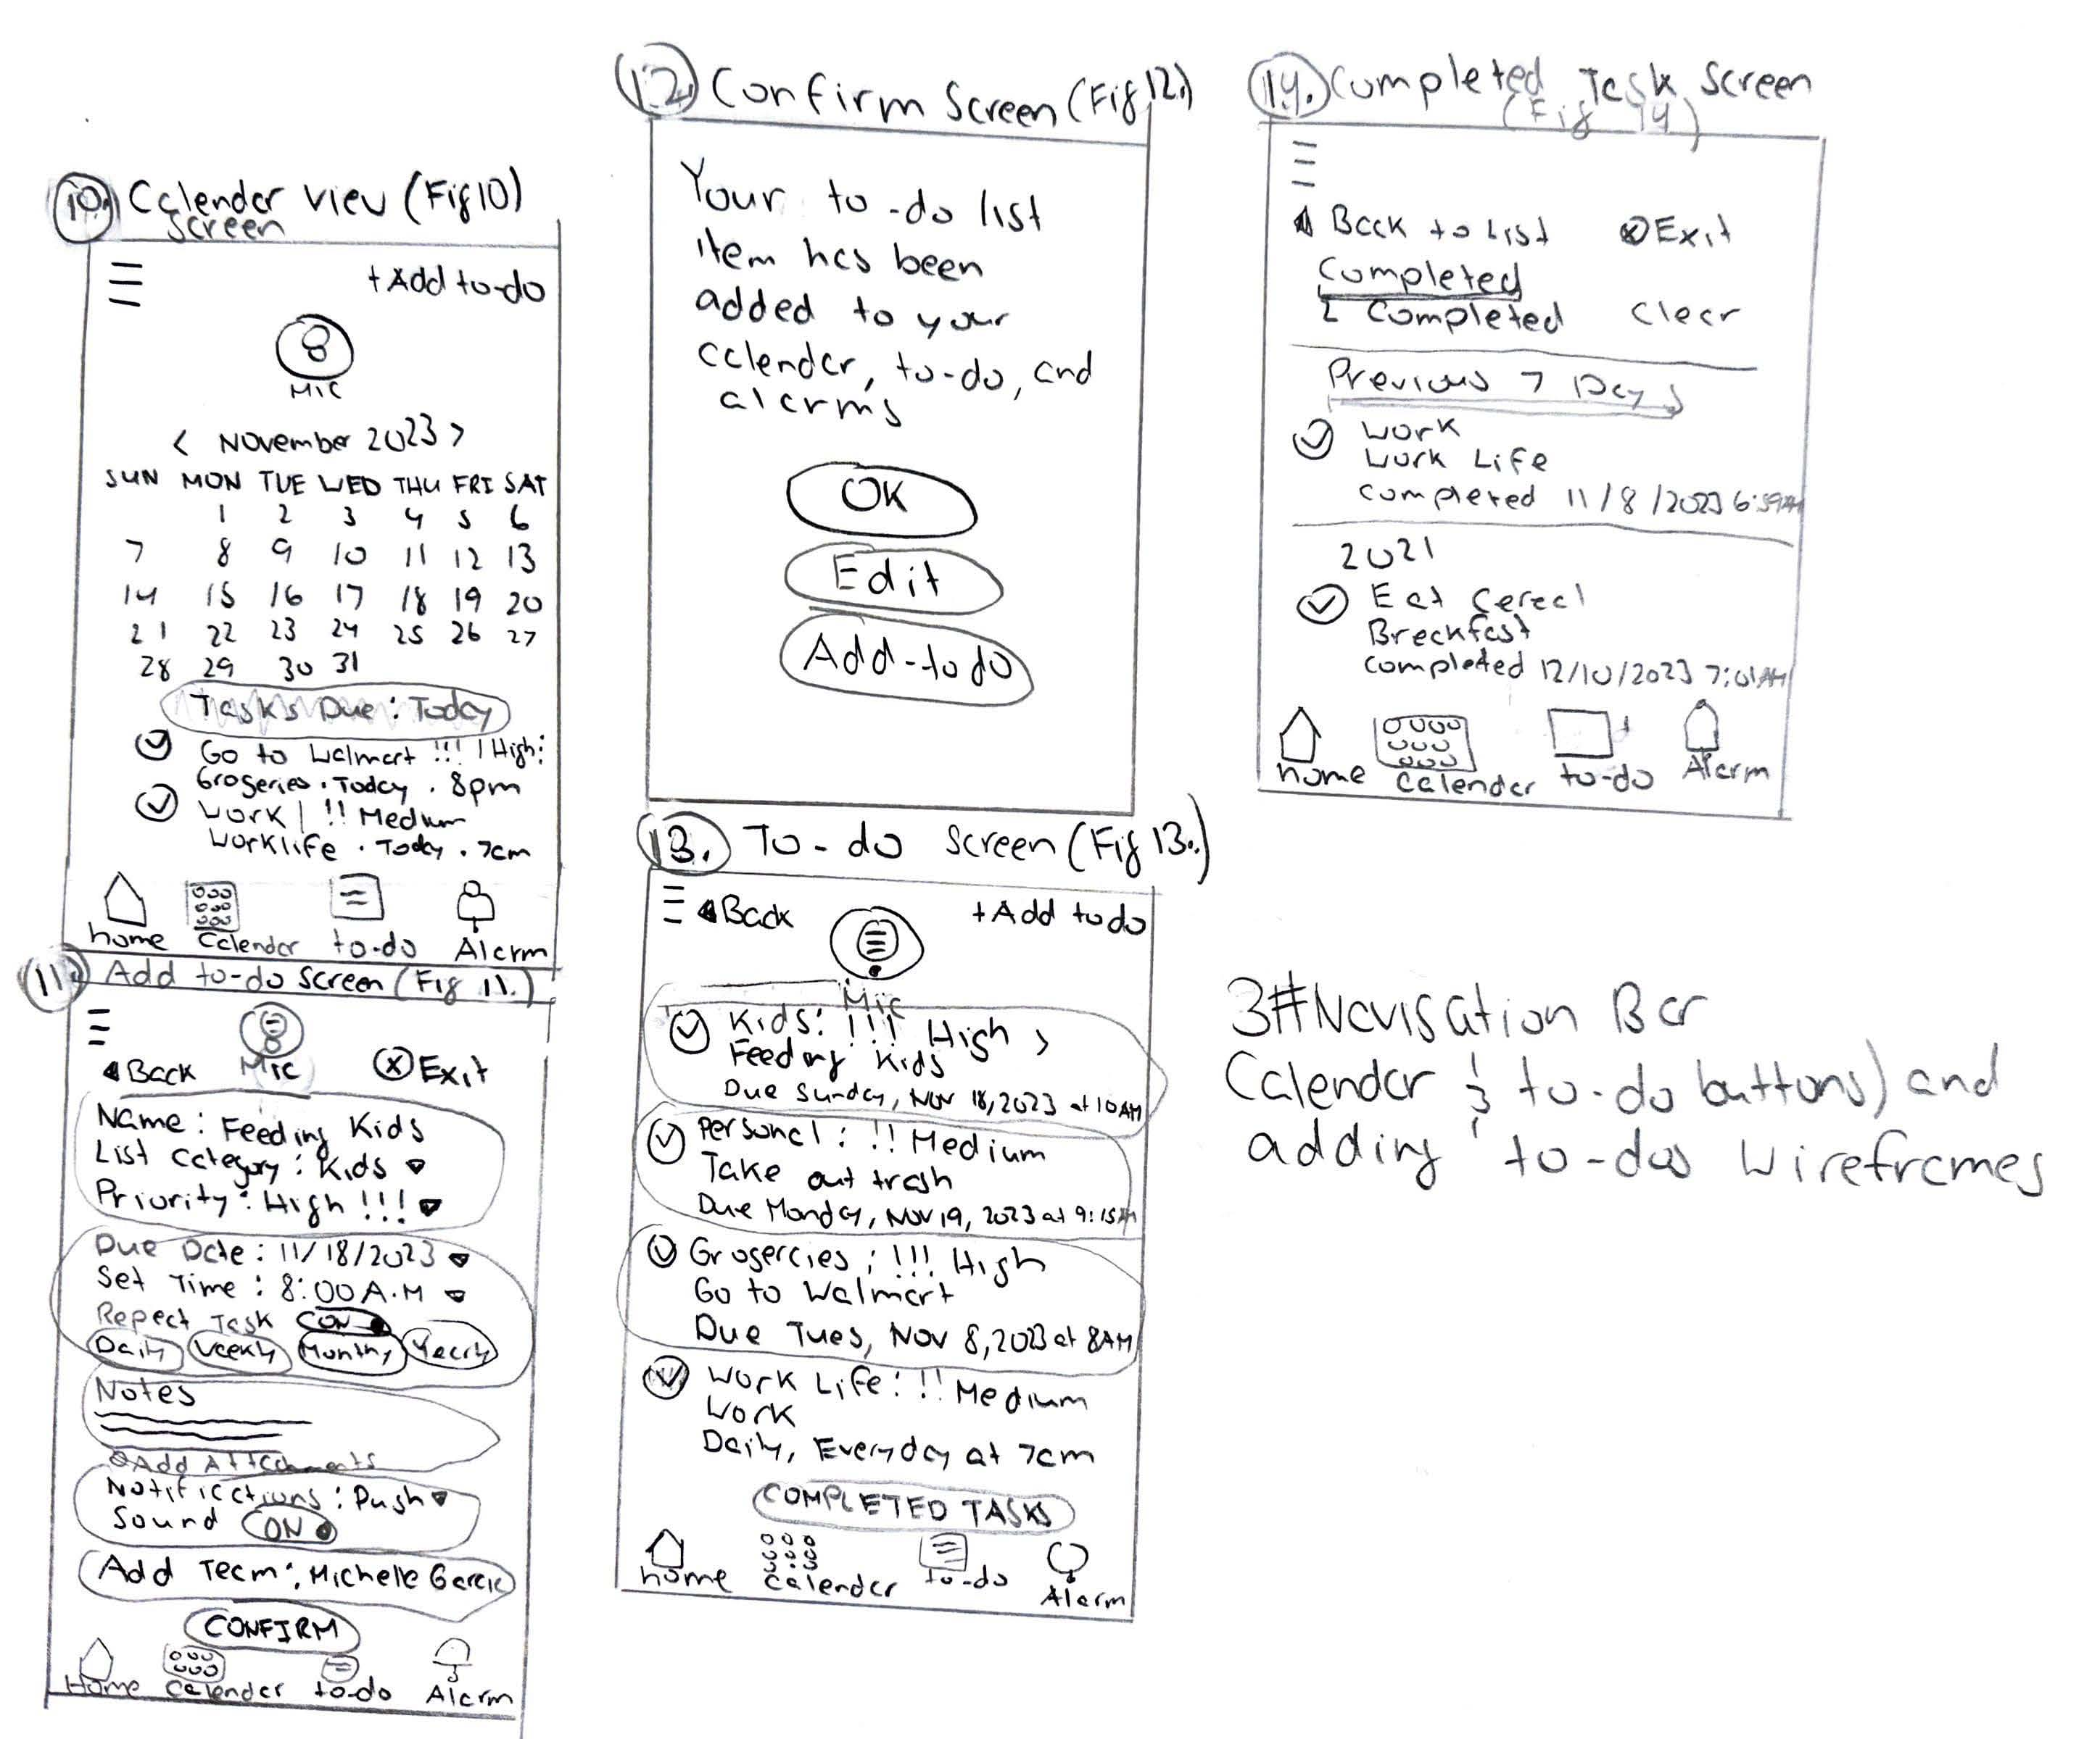

1. **Calendar View Screen (Fig 10)**

When the user selects the calendar button from the navigation, they will see a monthly calendar view where they can select the month and year. The user will be able to see recent and future tasks that are due. The user can select the "+ Add to do" link to be taken to the Add To-Do Screen, where they can fill out information for their new task.

1. **Add To-Do Screen (Fig 11)**

The user will see groupings of information to select options and enter their new task. If they select the "Back" link, they will return to the Calendar View Screen (Fig 9). If they select exit, they will go back to the Home Screen. The user can select the mic button to speak and enter their task that way. Once the user finishes entering their information for their task, they can select the confirm button.

# #3: Navigation Bar (Calendar & To-Do Buttons) and Adding To-Dos | Low-Fidelity– Continued



1. **Confirm Screen (Fig 12)**

When the user selects the confirm button, they will receive a notification that their to-do list item has been added to their calendar, to-do, and alarms. The user can select the following buttons: OK, Edit, or Add To-Do.

1. **To-Do Screen (Fig 13)**

When the user selects the To-Do button from the navigation, the user will see all their tasks. They have the option of selecting the checkmark to complete their tasks. Users can select the completed tasks button to see their completed tasks.

1. **Completed Tasks Screen (Fig 14)**

The user will see their completed task that displays the date and time. The user can select the "Back to List" link to go back to the To-Do Screen (Fig 13) or select the exit button to be taken back to the home screen.

# #4: Alarms Notifications | Low-Fidelity Wireframes

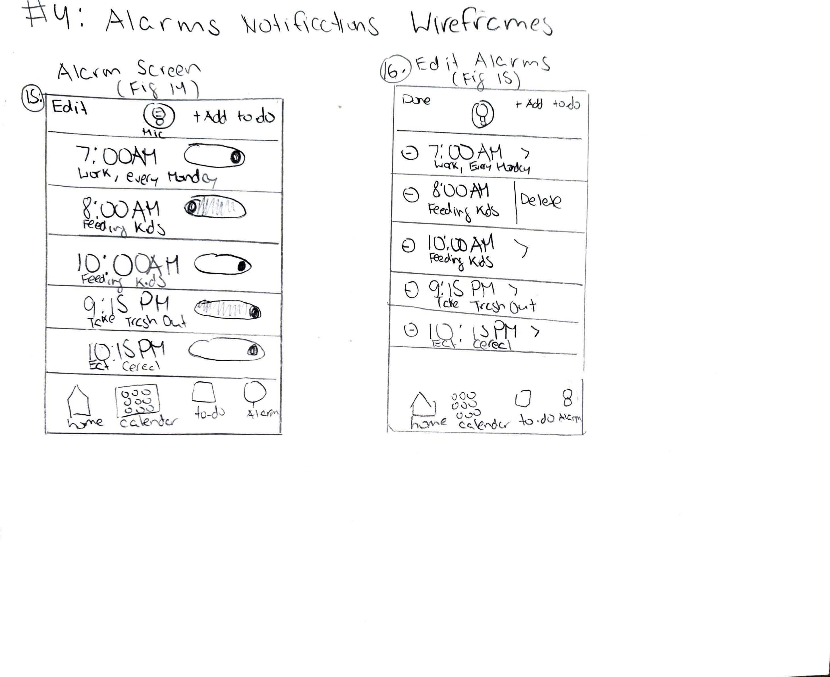

1. **Alarm Screen (Fig 15)**

When the user selects the Alarm button on the navigation, they will see all their alarms chronologically if they set a time to create their to-do item. The user can select the "Edit" link or the "+Add To-Do" link to create another to-do item.

1. **Edit Alarms (Fig 16)**

When the user selects the "Edit" link, they can delete their alarms by selecting the circular minus icon on the left side of their alarm. They can also tap the select alarm to change the notification updating the to-do item on the Calendar, To-Do, and Alarms screens.

High-Fidelity Wireframes

# #1: Getting Started | High-Fidelity Wireframes

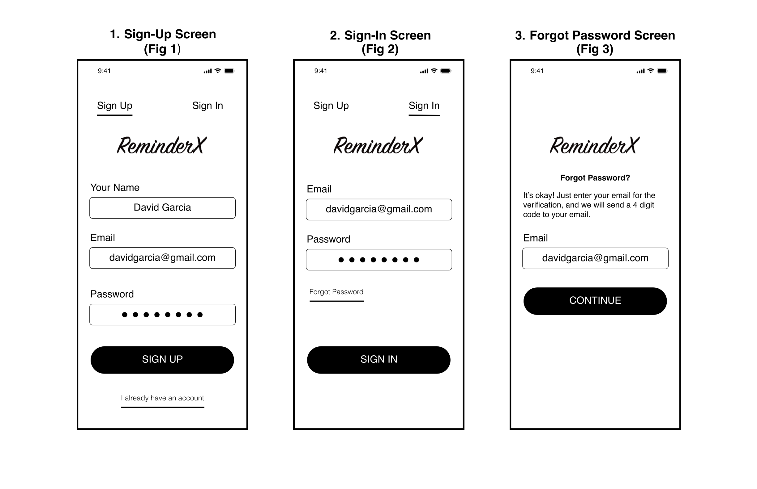

1. **Sign-Up Screen (Fig 1)**

The persona we created for ReminderX, David Garcia, has already downloaded the application to his phone. He can also access this application on his web browser. David is on the Sign-Up Screen, where he can create an account. David will enter his name and email and create a password. If an account is already created, David can select the “Sign In” link or the “I already have an account” link.

1. **Sign-In Screen (Fig 2)**

If David already has an account, he can enter his email and password and select the sign-in button to sign into his account. If David forgot his password, he can choose the “Forgot Password” link to help him reset it.

1. **Forgot Password Screen (Fig 3)**

David will be taken to the Forgot Password Screen, where he can enter his email to receive a 4-digit code for verification. He will select the continue button to enter the code he receives.

**View Interactive Protype:** [Select Here](https://xd.adobe.com/view/2238cef8-ea3d-44a9-9991-6aa3ed32c445-776b/)

# #1: Getting Started |High-Fidelity Wireframes – Continued

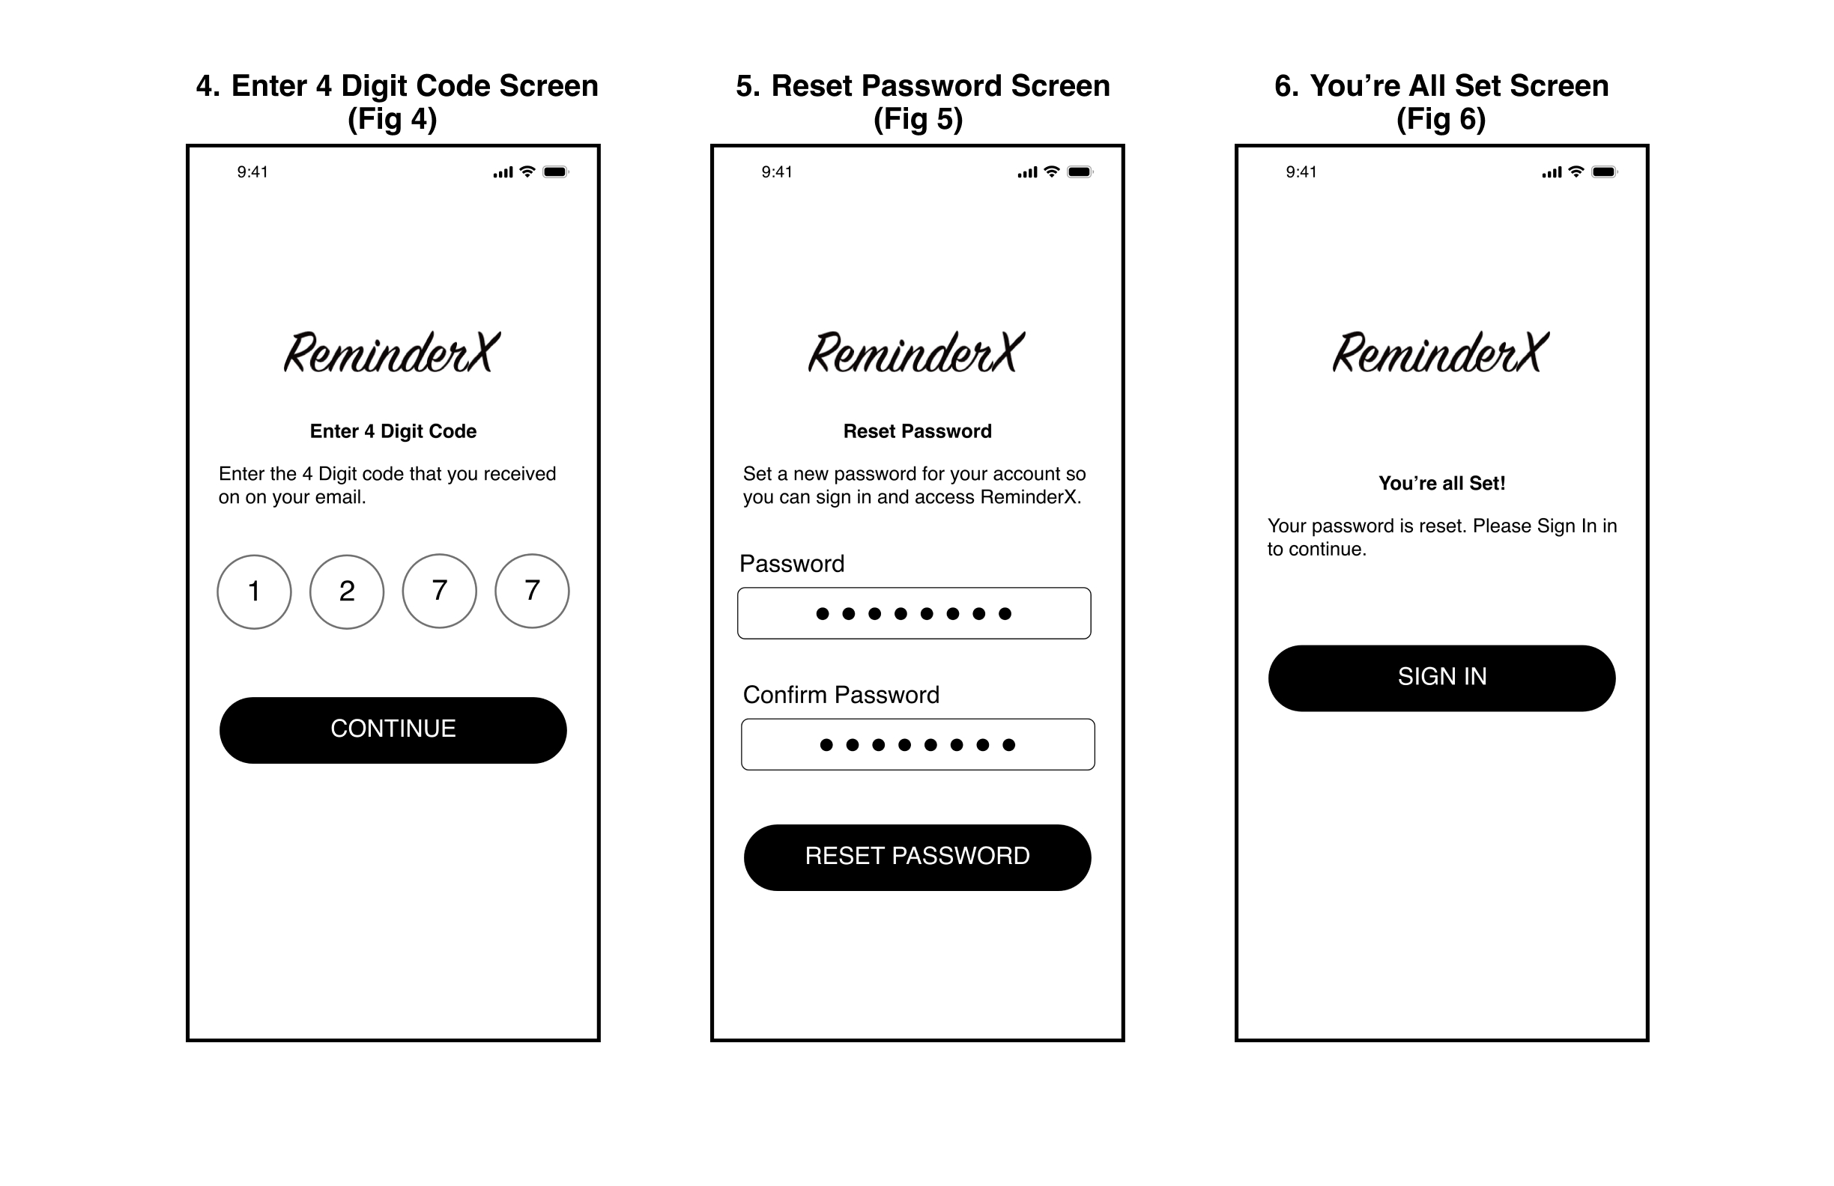

1. **Enter 4 Digit Code Screen (Fig 4)**

David will be able to enter the 4-digit code that he received from his email. Once he enters the code, he will select the continue button to proceed to reset his password.

1. **Reset Password Screen (Fig 5)**

David will be prompted to set and confirm a new password for his account. After he is done coming up with a password, he will select the reset button, allowing him to proceed to the next screen to sign into his account.

1. **You’re All Set Screen (Fig 6)**

After David resets his password, he can select the sign-in button to continue to access ReminderX.

**View Interactive Protype:** [Select Here](https://xd.adobe.com/view/2238cef8-ea3d-44a9-9991-6aa3ed32c445-776b/)

# #2: Home/How-To-Videos | High-Fidelity Wireframes

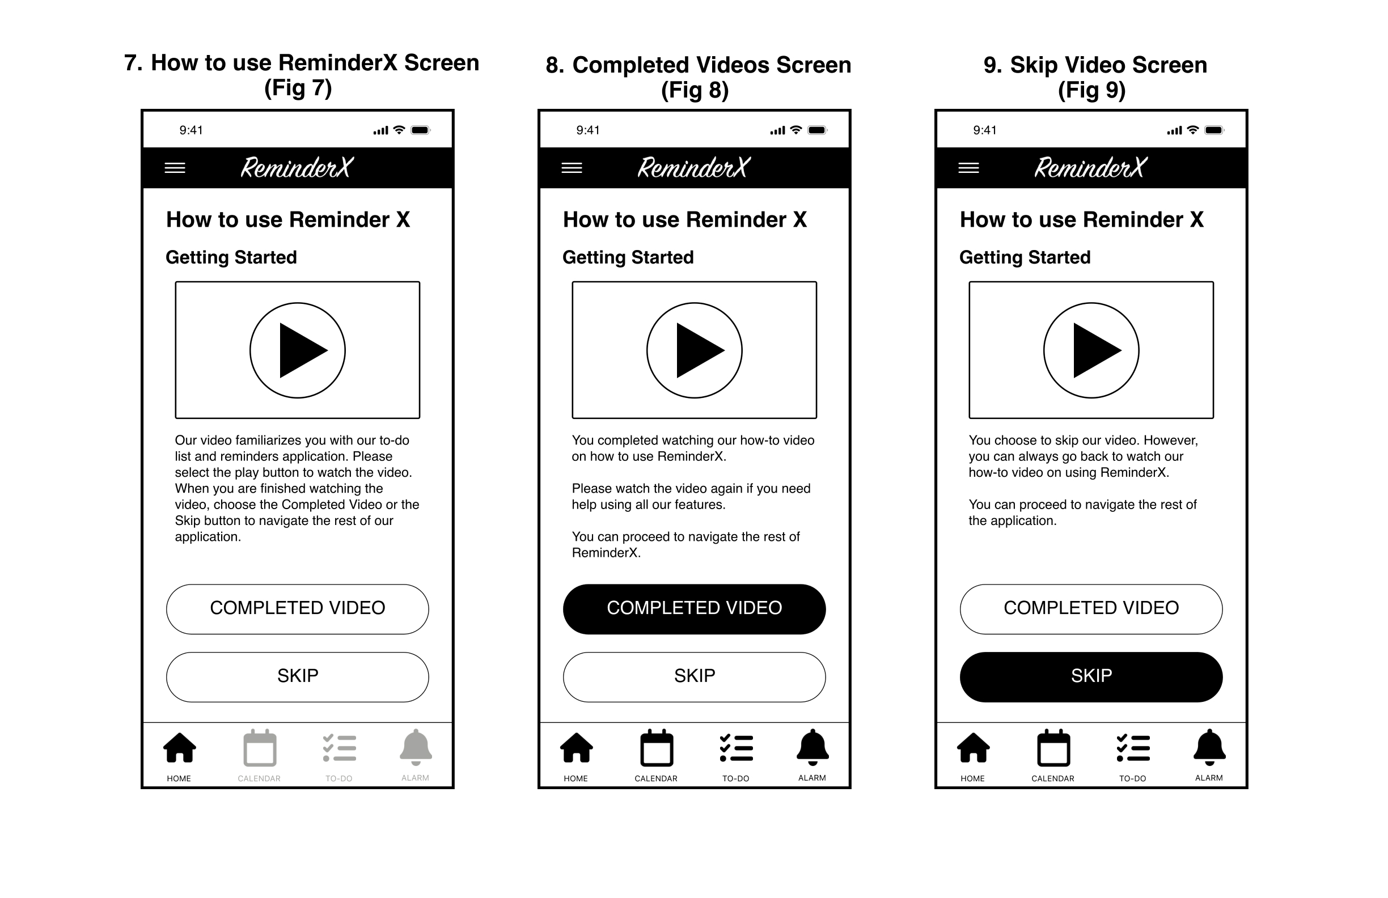

1. **How to use ReminderX Screen (Fig 7)**

David will arrive on the home screen, where he can play a video to help him familiarize himself with how to use ReminderX. On the navigation bar, the home button will only be the active button, while the rest of the navigation buttons will be turned off/grayed out.

David will see two options to choose from: the completed video or the skip button. When he completes watching the video, he can select the completed video button to proceed to navigate the rest of RemindeX. If David wishes not to watch the video, he can choose the skip button, allowing him to access the rest of the navigation bar to continue using ReminderX.

1. **Completed Videos Screen (Fig 8)**

David decides to watch the video and selects the completed video button. David will see the rest of the navigation bar be active for him to use the rest of the application. He can always go back to watch the video again.

1. **Skip Video Screen (Fig 9)**

If David doesn’t want to watch the how-to video to learn ReminderX, he can choose the skip button. By selecting this button, the navigation bar will be active for him to start using ReminderX.

**View Interactive Protype:** [Select Here](https://xd.adobe.com/view/2238cef8-ea3d-44a9-9991-6aa3ed32c445-776b/)

# #3: Navigation Bar (Calendar & To-Do Buttons) and Adding To-Dos | High-Fidelity Wireframes

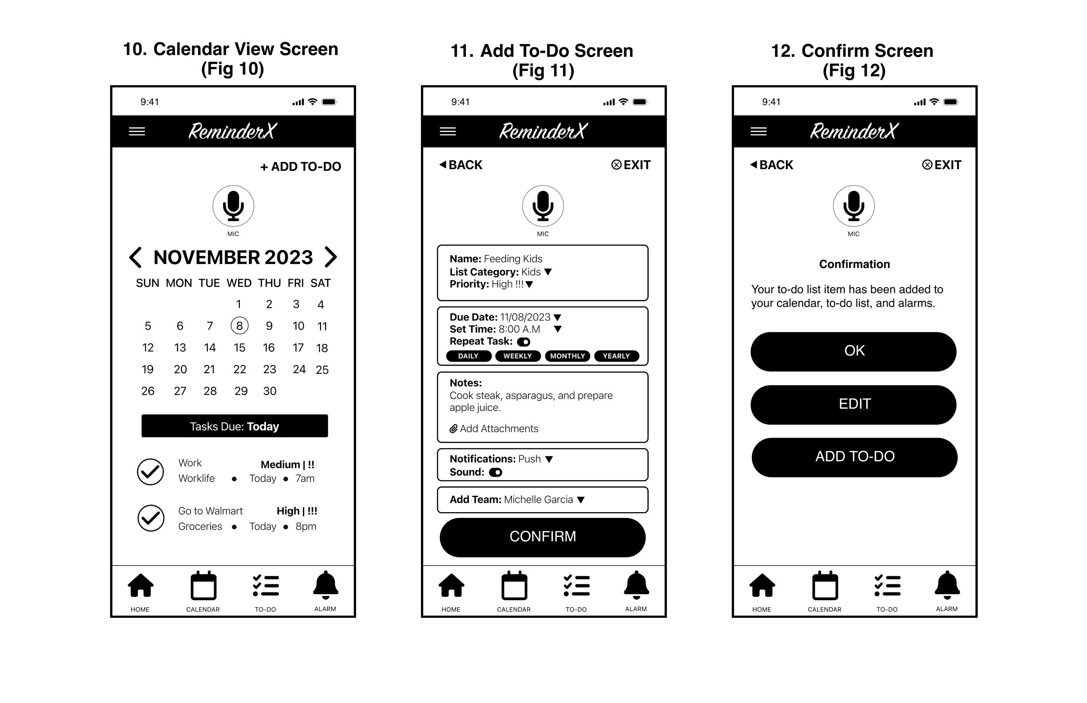

1. **Calendar View Screen (Fig 10)**

David selects the calendar button from the navigation bar. He will see a monthly overview of his tasks due today and future ones if he chooses a specific date. If he has tasks, he can select the checkmark icon to complete them, which will turn green, and it will move to the completed tasks section, where he can access this information when he chooses the to-do button. While on the calendar screen, David will see a mic button that will give him voice control and allow him to input commands. David will also see a “+ Add To-Do” link to create his to-do list items.

1. **Add To-Do Screen (Fig 11)**

When David selects the “+Add To-Do” link from the **Calendar View Screen (Fig 10),**he will see a grouping of boxes where he can add his to-do list item information. After he is done filling out his information, he can select the confirm button.

On the Add To-Do Screen, he can select the “Back” link that will go back to the **Calendar View Screen (Fig 10**), and if he chooses the “Exit” link, this will take him back to the home screen**(Completed** **Videos (Fig 8) or (Skip Video (Fig 9))**depending on which option David chose in the beginning.

**View Interactive Protype:** [Select Here](https://xd.adobe.com/view/2238cef8-ea3d-44a9-9991-6aa3ed32c445-776b/)

# #3: Navigation Bar (Calendar & To-Do Buttons) and Adding To-Dos | High-Fidelity Wireframes – Continued

1. **Confirm Screen (Fig 12)**

After David selects the confirm button from the **Add To-Do Screen (Fig 11),**the to-do list item he created will be added to his calendar, to-do, and alarms. He has three options to select from, which will be the “OK”, “Edit”, or “Add-To-Do” buttons.

The “OK” button will confirm the to-do list item he made. The “Edit” button will allow him to edit his to-do list item, and the “Add-To-Do” button will allow him to create another to-do item.

**View Interactive Protype:** [Select Here](https://xd.adobe.com/view/2238cef8-ea3d-44a9-9991-6aa3ed32c445-776b/)

# #3: Navigation Bar (Calendar & To-Do Buttons) and Adding To-Dos | High-Fidelity Wireframes – Continued

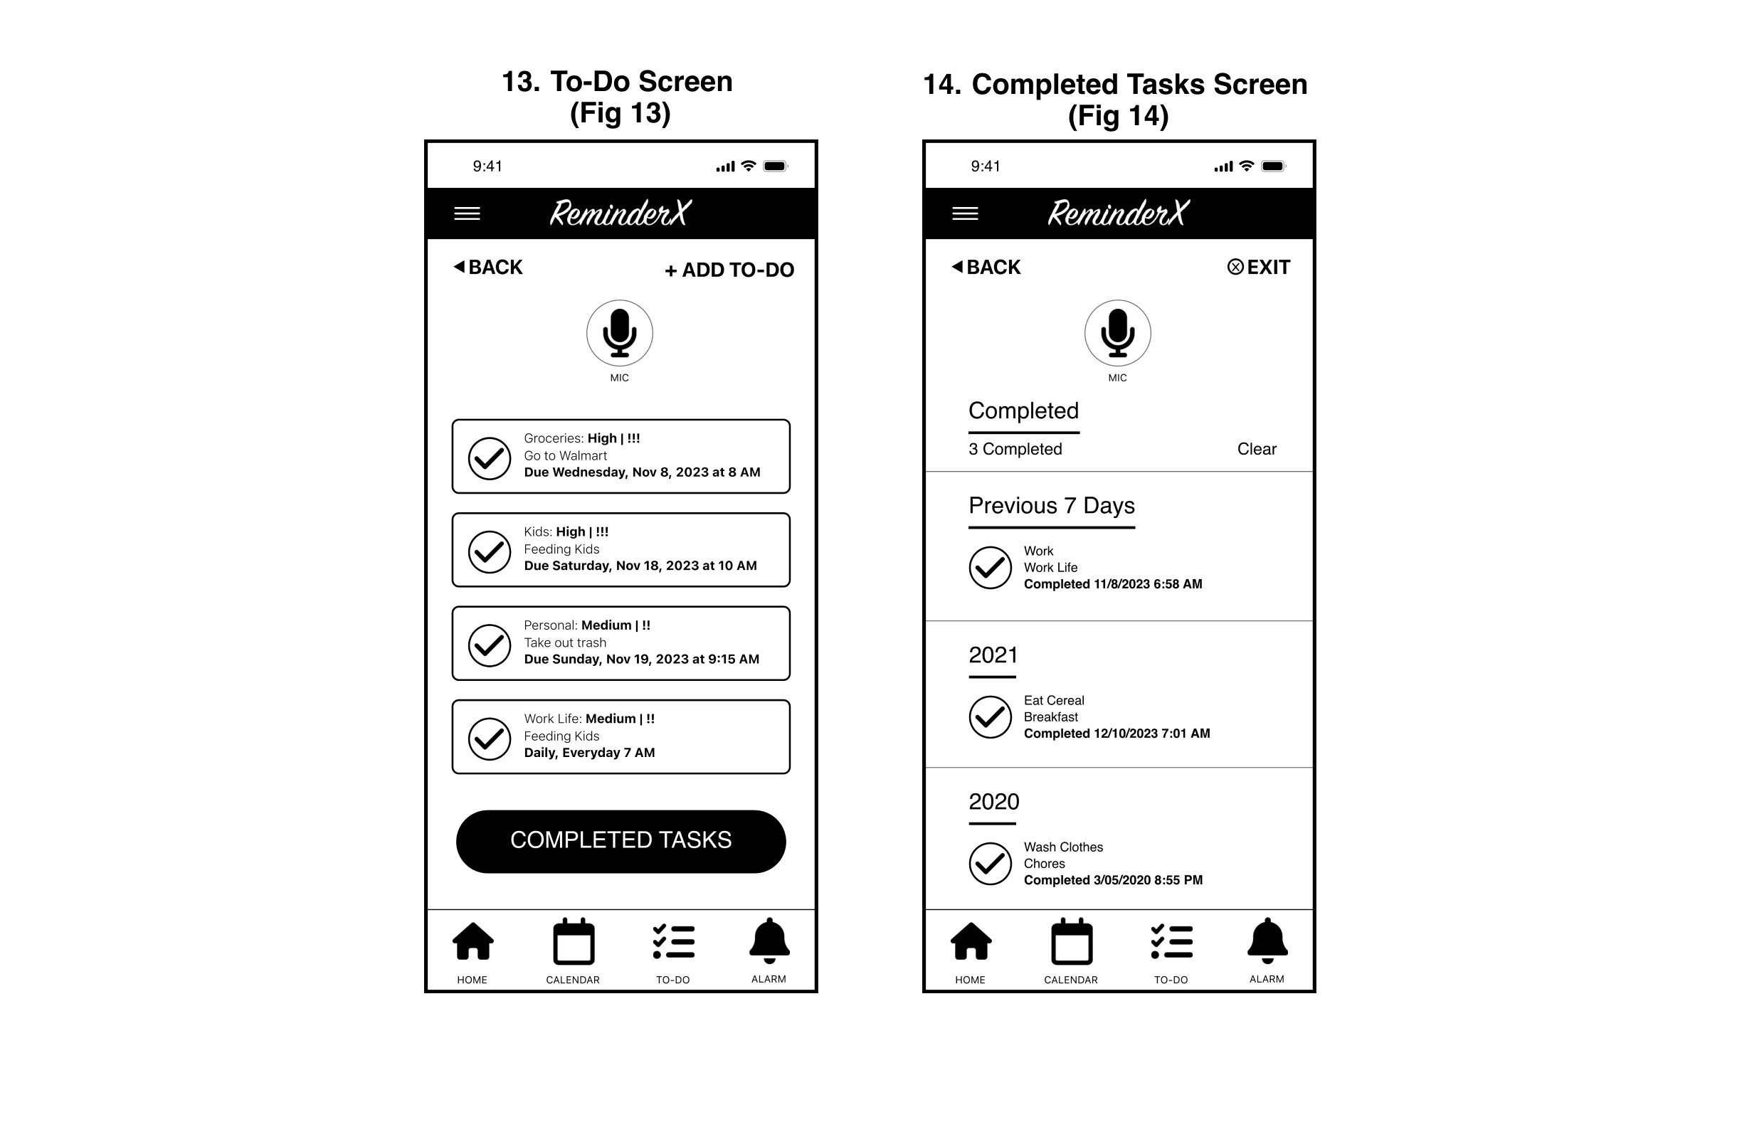

1. **To-Do Screen (Fig 13)**

When David selects the to-do button from the navigation, he will see each task he created and needs to complete. On each task, David will see a checkmark icon that he can select, and it will turn green. When he chooses the completed tasks button, David's task will be moved to the **Completed Task Screen (Fig 14)**.

1. **Completed Tasks Screen (Fig 14)**

After David selects the completed tasks button from the **To-Do Screen (Fig 13)**, he will see all the to-do list items he completed the previous week and in the years. David can choose the “Back” link to return to the **To-Do Screen (Fig 13)** or select the “Exit” link to return to the home screen.

**View Interactive Protype:** [Select Here](https://xd.adobe.com/view/2238cef8-ea3d-44a9-9991-6aa3ed32c445-776b/)

# #4: Alarms Notifications | High-Fidelity Wireframes

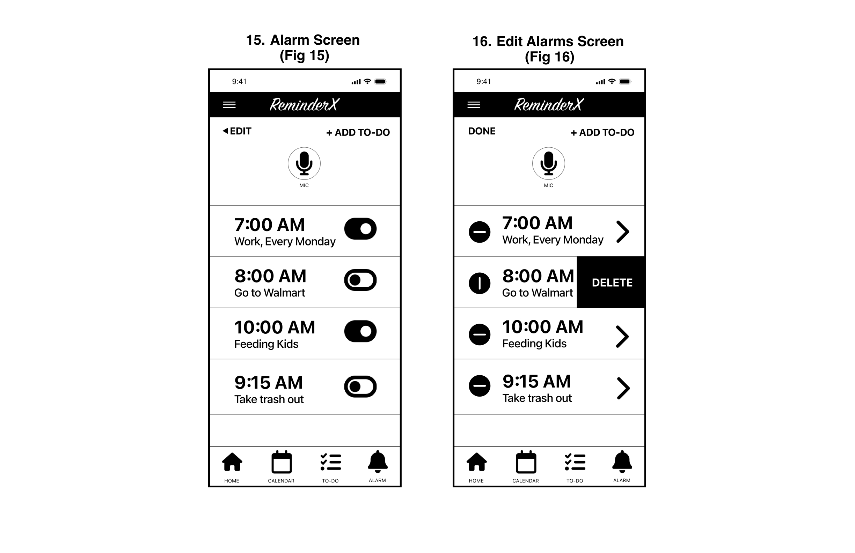

1. **Alarm Screen (Fig 15)**

When David chooses the alarm button from the navigation, he will see all the to-do list items he set a time for when he created the items from the to-do button. David can turn/off the alarms by toggling the on/off icon. From this screen, he can choose the “Edit” link to delete alarms or edit them. Also, he can select the “+Add To-Do” link to add another to-do list item.

1. **Edit Alarms Screen (Fig 16)**

When David chooses the “Edit” link from the **Alarm Screen (Fig 15),** he can edit or delete his alarm. He will see a minus icon on the alarms, and when he selects the minus icon, it will rotate vertically, and he will be able to delete his alarm. David can edit his selection if he taps the arrow on the alarm. When finished, David can select the “Done” link to return him to the **Alarm Screen (Fig 15)**.

**View Interactive Protype:** [Select Here](https://xd.adobe.com/view/2238cef8-ea3d-44a9-9991-6aa3ed32c445-776b/)

Prototypes

# Interactive Prototype

Kimberley Johnson and the design team picked Adobe XD to make the final prototypes for ReminderX because Adobe XD lets the team work together efficiently and quickly.

Adobe XD also works well with other Adobe tools, making it easy to keep a consistent design throughout the ReminderX project.

[Select Here to View the Interactive Prototype of ReminderX.](https://xd.adobe.com/view/2238cef8-ea3d-44a9-9991-6aa3ed32c445-776b/)

Lessons Learned

# What I Learned

While starting the process of designing a to-do list and reminder application, it was challenging for me to incorporate all the necessities the user would like to feature for this application and visualize it.

After interviewing participants, it became easier to design core features and how users would like to integrate them with other applications from their phones. At first, developing interview questions for the participants who participated in my user study was challenging. My interview questions were redundant, but after receiving the feedback from my professor, he advised me to ask follow-up questions because my interviews were short.

I learned that designing in Adobe XD has been a smooth experience because it was my first time using this software to create wireframes and an interactive prototype.

I enjoyed working on ReminderX; it helped me understand the design process of what a UX Designer works on.